1. Select Your Operating System (OS): Choose an operating system that best suits your preferences and project requirements. Download and Install Windows 11. <https://www.microsoft.com/software-download/windows11>

I am using MacOS. This is not applicable

1. Install a Text Editor or Integrated Development Environment (IDE): Select and install a text editor or IDE suitable for your programming languages and workflow. Download and Install Visual Studio Code. <https://code.visualstudio.com/Download>

* Go to the VS code official website.
* Go to downloads
* Download the option for mac
* 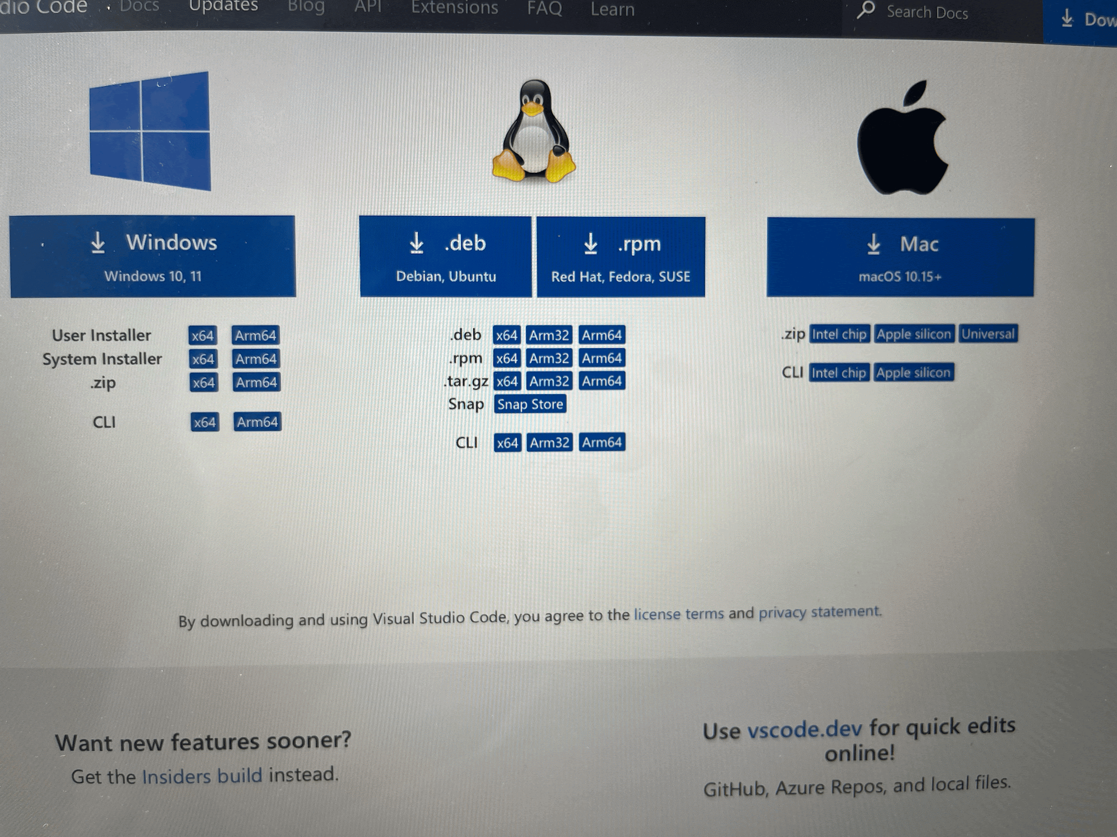
* When it downloads, double click to extract the VS code app from the .zip file, and then drag it into applications. You can then open it from there
* Press Cmd + Shift + P to open the Command Palette. Then type Shell Command: Install 'code' command in PATH. this will allow you to open VS code from the mac terminal

1. Set Up Version Control System: Install Git and configure it on your local machine. Create a GitHub account for hosting your repositories. Initialize a Git repository for your project and make your first commit. [https://github.com](https://github.com/)

To install Git on macos, go to the Git website and choose mac. It will instruct you to use homebrew

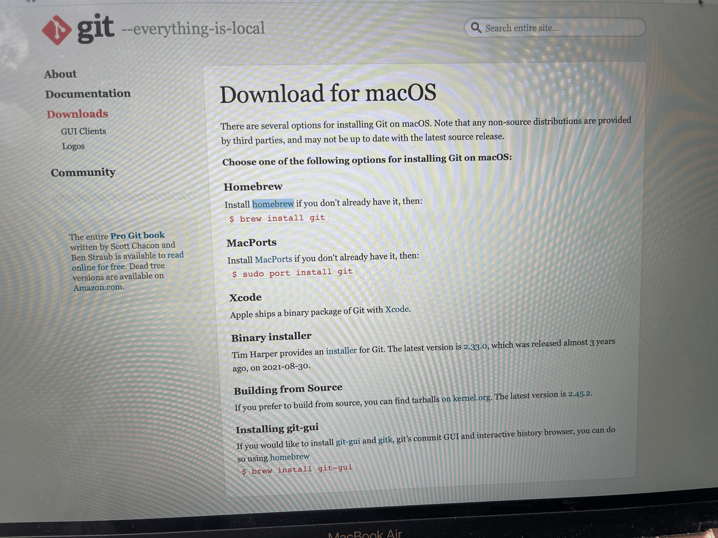

Go to the homebrew website and paste the link on the website onto your terminal to install homebrew

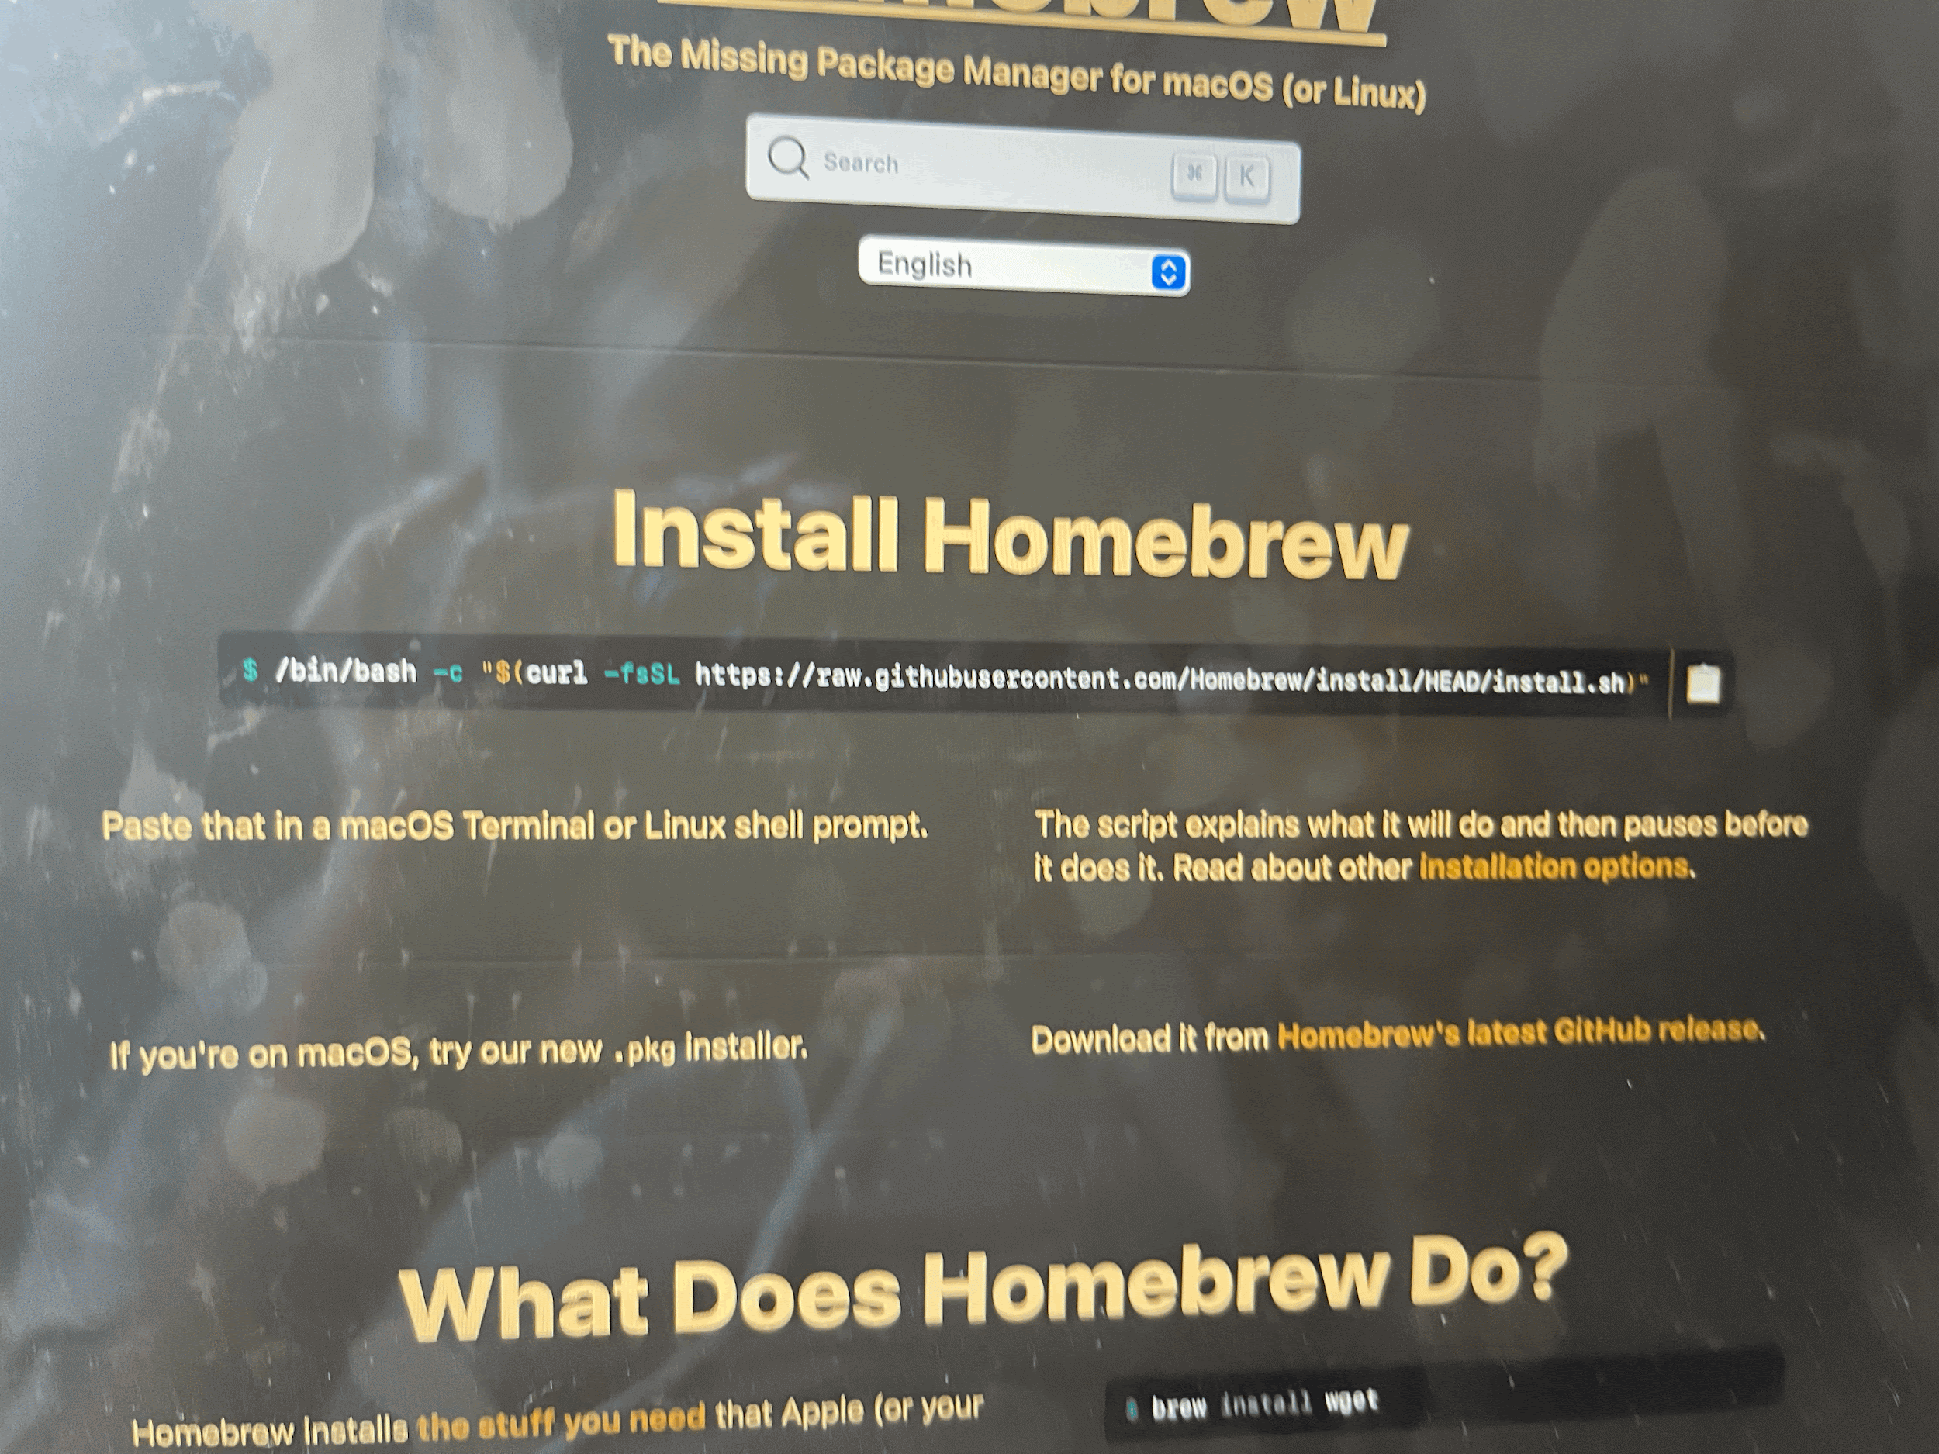

Once homebrew is installed, type the command brew install git

To configure git type the command

git config --global user.name "Your Name"

then

git config --global user.email "your.email@example.com"

Then go to the github website and sign up and create your account by following the instructions

To initialize a repo, first change directory to the desired directory by using cd

The type the command git init

Make the required changes to the file

Then git add .

Then git push

Then git commit -m “commit message”

1. Install Necessary Programming Languages and Runtimes: Instal Python from [http://wwww.python.org](http://wwww.python.org/)programming language required for your project and install their respective compilers, interpreters, or runtimes. Ensure you have the necessary tools to build and execute your code.

Go to the python website and download python for macos

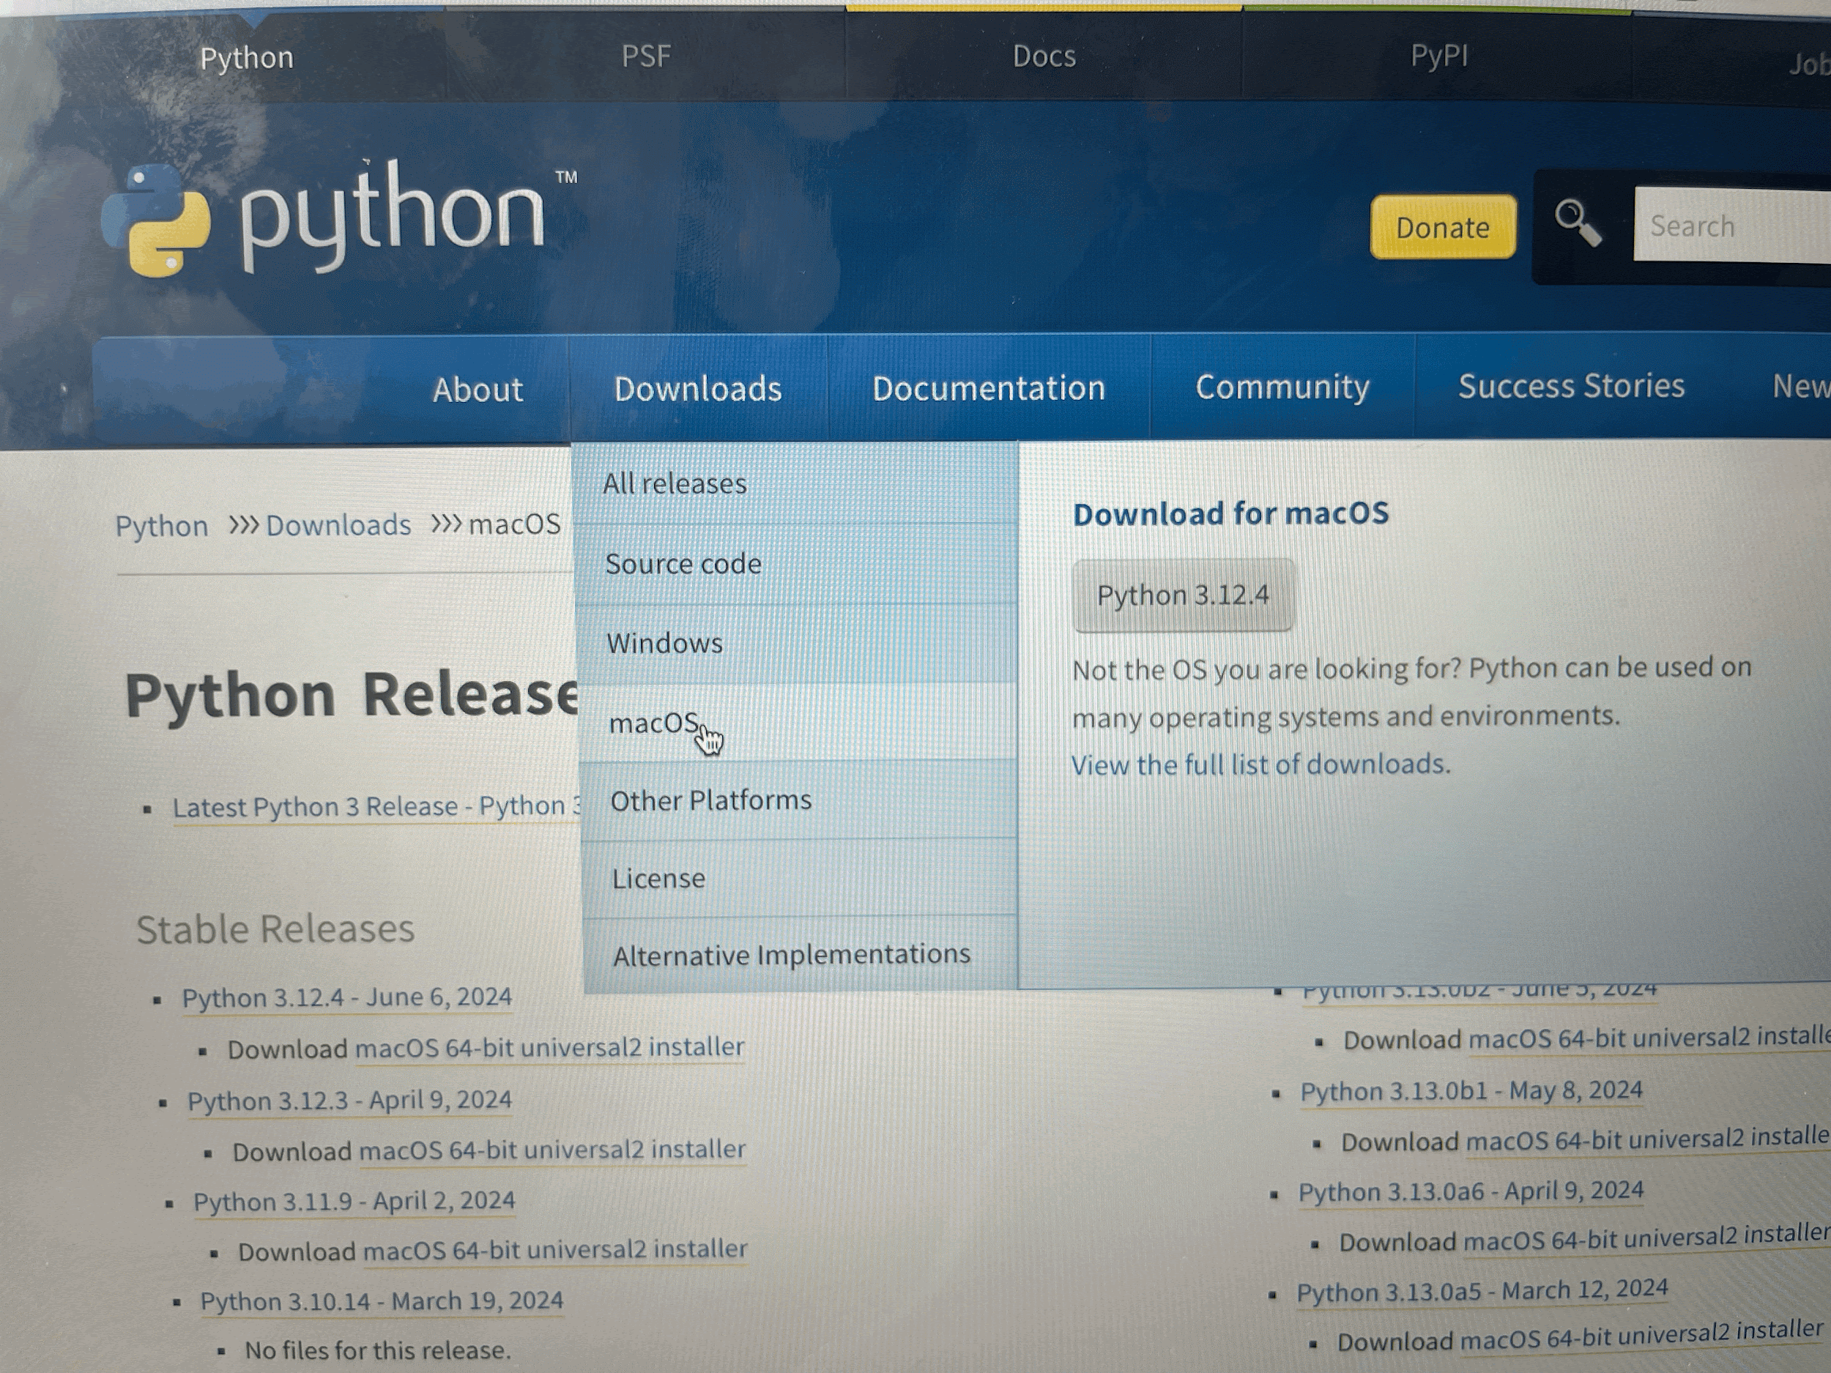

Open the python pkg file and follow the instructions to setup

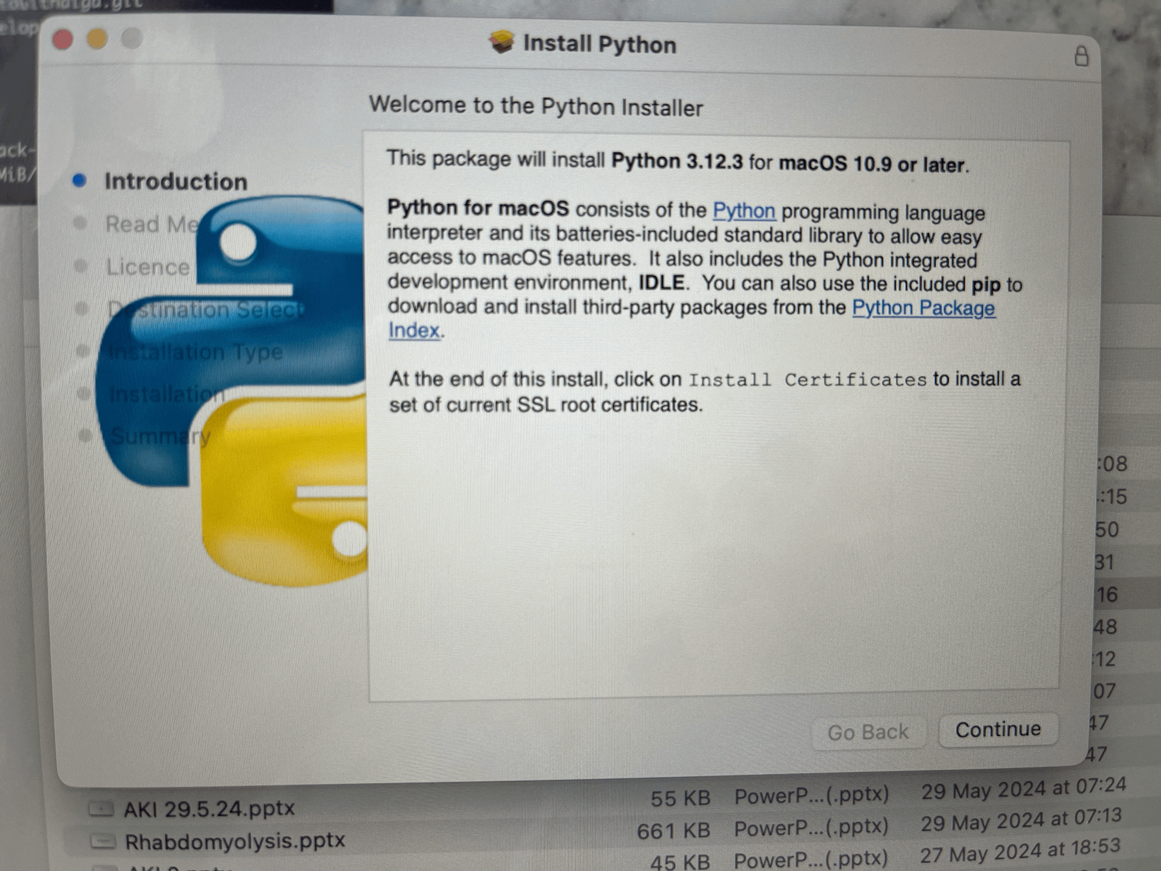

Once done, go to the terminal and type python3 –version to confirm installation

1. Install Package Managers: If applicable, install package managers like pip (Python).

First check if pip is installed by typing into your terminal pip3 –version

If pip is not installed run the command

curl https://bootstrap.pypa.io/get-pip.py -o get-pip.py

Followed by

python3 get-pip.py

1. Configure a Database (MySQL): Download and install MySQL database. <https://dev.mysql.com/downloads/windows/installer/5.7.html>

Download Mysql from the mysql website

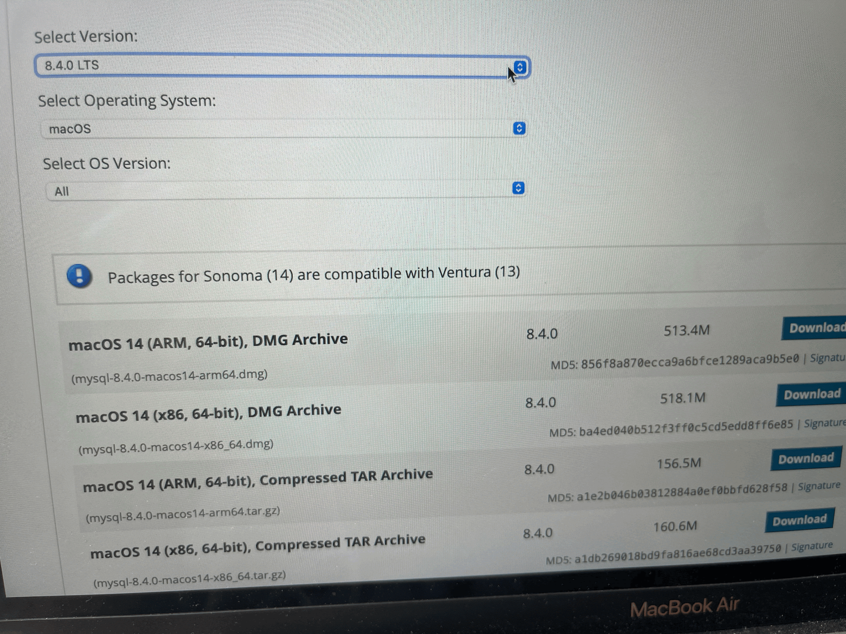

Open the downloaded DMG file and run the installer. Follow the on-screen instructions to complete the installation

Configure the settings and type a password you can rememer

1. Set Up Development Environments and Virtualization (Optional): Consider using virtualization tools like Docker or virtual machines to isolate project dependencies and ensure consistent environments across different machines.

Not done

1. Explore Extensions and Plugins: Explore available extensions, plugins, and add-ons for your chosen text editor or IDE to enhance functionality, such as syntax highlighting, linting, code formatting, and version control integration.

I have downloaded several extension onto my Vs code including coderunner, pylsnce, python debugger, python image preview, dart and flutter.

1. Document Your Setup: Create a comprehensive document outlining the steps you've taken to set up your developer environment. Include any configurations, customizations, or troubleshooting steps encountered during the process.

#Deliverables:

* Document detailing the setup process with step-by-step instructions and screenshots where necessary.

- done above

* A GitHub repository containing a sample project initialized with Git and any necessary configuration files (e.g., .gitignore).

https://github.com/RitaGithaiga/assignment-1.git

* A reflection on the challenges faced during setup and strategies employed to overcome them.
  + My main challenges were finding out how to do the steps down in class to setup the environment on windows OS, on my mac os. I used chatgpt, gemini, youtube videos, and reddit to figure it out.
  + When all failed i went through the telegram chat to see if anyone had encountered a similar problem and how they had solved it.
  + Another challenge was when i tried to commit my changes in git, it failed, but i realized that i had to select autosave for it to work.

#Submission: Submit your document and GitHub repository link through the designated platform or email to the instructor by the specified deadline.

#Evaluation Criteria:**

* Completeness and accuracy of setup documentation.
* Effectiveness of version control implementation.
* Appropriateness of tools selected for the project requirements.
* Clarity of reflection on challenges and solutions encountered.
* Adherence to submission guidelines and deadlines.